PROJECT DOCUMENTATION by AKILANDESWARI M
EduGenie
Google Gemini Powered Learning Assistant
Ask • Explain • Summarize • Quiz • Learning Path

Built with FastAPI | HTML, CSS and JavaScript | Google Gemini API

Version 1.0

Contents
1 Introduction and Objective
2 Key Features
3 Technology Stack
4 System Architecture
5 Project Structure
6 Module Details with Code
7 REST API Reference
8 Web Portal Output
9 Setup and Run Locally
10 Deployment on Render
11 Demo Guide
12 Troubleshooting
13 Future Enhancements
14 Conclusion

1. Introduction and Objective
EduGenie is a lightweight, AI-powered educational assistant. It helps learners ask questions, understand difficult concepts, summarize study material, test their knowledge and follow a structured learning path, all from one calm and simple web page.
The application uses the Google Gemini API for content generation and a FastAPI backend to connect the browser to five focused learning modules.

Project objective
Build an educational assistant that helps learners ask questions, understand difficult concepts, summarize study material, test their knowledge, and follow structured learning paths.

Why EduGenie
- One place for five study tasks, so students do not switch between tools.
- Beginner-friendly language in every response.
- Automatic model fallback, so the app keeps working if one Gemini model is unavailable.
- Simple to deploy, with a ready Render blueprint and a health-check endpoint.

2. Key Features
Feature | What it does | Endpoint
Smart Q&A | Gives a direct, student-friendly answer to any educational question. | POST /qa
Simple Explanations | Explains a topic in 5 fixed sections: definition, how it works, example, key points, recap. | POST /explain
Instant Summaries | Turns long study text into short revision notes with a one-line takeaway. | POST /summarize
Interactive Quizzes | Creates exactly 3 MCQs with 4 options each and shows instant feedback and a score. | POST /quiz
Learning Paths | Builds a roadmap from prerequisites to a final project, with weekly schedule. | POST /learn/recommendations

Other highlights
- Responsive, presentation-ready interface.
- Interactive FastAPI documentation at /docs.
- Health check at /health for deployment platforms.
- Secrets are kept in environment variables, never in source code.

3. Technology Stack
Layer | Technology | Purpose
Frontend | HTML5, CSS3, JavaScript | Page structure, responsive design, API calls and quiz interaction
Backend | Python, FastAPI, Uvicorn | REST API and ASGI server
Templates | Jinja2 | Serves the main page (index.html)
AI | Google Gemini API (google-genai SDK), Gemini 3.8 Flash | Generates answers, explanations, summaries, quizzes and paths
Validation | Pydantic | Request model and quiz response schema
Config | python-dotenv | Loads GEMINI_API_KEY and GEMINI_MODEL from .env
Hosting | Render | Cloud deployment via render.yaml

Python dependencies (requirements.txt)
requirements.txt
fastapi
uvicorn[standard]
jinja2
python-dotenv
google-genai
pydantic

4. System Architecture
EduGenie follows a simple request and response pipeline. Each learning tool has its own small Python module, which keeps the code easy to read and extend.
Browser  HTML / CSS / JS | ▶ | FastAPI  main.py | ▶ | Module  qna, quiz, ... | ▶ | Gemini API  gemini_utils.py | ▶ | Response  JSON to browser

How a request flows
- The user picks a tool (Ask, Explain, Summarize, Quiz or Learn Path) and enters text.
- JavaScript sends a POST request to the matching FastAPI endpoint.
- FastAPI validates the body with Pydantic (TextRequest) and checks that Gemini is configured.
- The endpoint calls the matching Python module, which builds an educational prompt.
- generate_with_fallback() sends the prompt to Gemini, trying backup models if needed.
- The result is returned as JSON, and the frontend renders it in the response panel.

5. Project Structure
EduGenie/
EduGenie/
|-- main.py FastAPI app and endpoints
|-- gemini_utils.py Model list and fallback logic
|-- qna.py Question answering
|-- explanation_module.py Beginner explanations
|-- summary_module.py Revision summaries
|-- quiz_module.py 3-question MCQ quiz (structured output)
|-- learning_path.py Learning roadmap
|-- requirements.txt Python dependencies
|-- render.yaml Render deployment blueprint
|-- .env.example Environment variable template
|-- .gitignore
|-- README.md
|-- templates/
| `-- index.html Main web page
`-- static/
|-- style.css Responsive styling
`-- app.js Frontend logic and quiz interaction

Module mapping
File | Responsibility
main.py | Creates the FastAPI app, CORS, static files, templates and all REST endpoints.
gemini_utils.py | Normalizes model names and retries with fallback Gemini models.
qna.py | General educational question answering.
explanation_module.py | Turns difficult topics into beginner-friendly explanations.
summary_module.py | Creates concise, revision-oriented summaries.
quiz_module.py | Generates exactly three MCQs with four options each, validated by Pydantic.
learning_path.py | Generates a beginner-to-advanced learning roadmap.

6. Module Details with Code
This section shows the most important code from the project.

6.1 Application setup (main.py)
The app loads the API key from .env, creates the Gemini client only when a key exists, and defaults to the model gemini-3.8-flash.
main.py: configuration
load_dotenv(BASE_DIR / ".env")

API_KEY = os.getenv("GEMINI_API_KEY")
MODEL_NAME = os.getenv("GEMINI_MODEL") or "gemini-3.8-flash"
client = genai.Client(api_key=API_KEY) if API_KEY else None

app = FastAPI(
title="EduGenie",
description="Google Gemini Powered Learning Assistant",
version="1.0.0",
)

6.2 Endpoint pattern (main.py)
Every endpoint follows the same three steps: validate the input, make sure Gemini is configured, then call the module and return JSON.
main.py: /qa endpoint and helpers
class TextRequest(BaseModel):
text: str

@app.post("/qa")
async def qa(request: TextRequest):
validate_text(request.text, "question")
require_gemini_client()
try:
return {"success": True,
"result": answer_question(client, request.text, MODEL_NAME)}
except Exception as exc:
raise HTTPException(status_code=500, detail=safe_error(exc))

def validate_text(value: str, field_name: str) -> None:
if not value or not value.strip():
raise HTTPException(status_code=400,
detail=f"Please enter a {field_name}.")

6.3 Automatic model fallback (gemini_utils.py)
If the chosen model is missing, rate-limited or temporarily unavailable, EduGenie tries the next model in the list instead of failing.
gemini_utils.py: fallback list and retry loop
DEFAULT_MODELS = [
"gemini-3.8-flash",
"gemini-3.5-flash-lite",
"gemini-3.5-flash",
"gemini-2.5-flash",
]

def generate_with_fallback(client, prompt, preferred_model=None,
*, response_schema=None):
last_error = None
for model_name in get_model_candidates(preferred_model):
try:
request_kwargs = {"model": model_name, "contents": prompt}
if response_schema is not None:
request_kwargs["config"] = {
"response_mime_type": "application/json",
"response_schema": response_schema,
}
return client.models.generate_content(**request_kwargs)
except Exception as exc:
last_error = exc
if _should_try_next_model(exc):
continue
raise
raise last_error

Retry rules: the next model is tried on HTTP 404, 429, 500, 502, 503 or 504, or when the error message mentions "not found", "unsupported" or "unavailable".

6.4 Smart Q&A (qna.py)
qna.py
def answer_question(client, question: str, model_name: str) -> str:
prompt = f"""
You are EduGenie, an educational AI assistant.

Answer the student's question accurately and clearly.

Student question:
{question}

Instructions:
- Give the direct answer first.
- Use simple, student-friendly language.
- Explain difficult terms when necessary.
- Use short sections or bullets when helpful.
- Do not unnecessarily make the response long.
"""
response = generate_with_fallback(client, prompt, model_name)
return response.text or "No answer was generated."

6.5 Explanation, summary and learning path
Module | Prompt design
explanation_module.py | Tutor persona. Forces exactly 5 sections: Simple definition, How it works, Easy example, Important points, Quick recap.
summary_module.py | Preserves facts, removes repetition, uses bullets and ends with a one-sentence revision takeaway.
learning_path.py | 7 sections (prerequisites to final project). Each level lists topics, outcomes and time. Recommends resource types only and never invents URLs.

6.6 Quiz with structured output (quiz_module.py)
The quiz uses a Pydantic schema so Gemini must return valid JSON with exactly 3 questions and 4 options each. The reply is validated before it is sent to the browser.
quiz_module.py: schema and generation
class QuizQuestion(BaseModel):
question: str
options: List[str] = Field(min_length=4, max_length=4)
correct_answer: str

class QuizResponse(BaseModel):
questions: List[QuizQuestion] = Field(min_length=3, max_length=3)

def generate_quiz(client, topic: str, model_name: str) -> dict:
prompt = f"""Create a student-friendly multiple-choice quiz about:
{topic}
... Exactly 3 questions, exactly 4 options, one correct answer ..."""

response = generate_with_fallback(
client, prompt, model_name, response_schema=QuizResponse,
)
quiz = QuizResponse.model_validate_json(response.text)
return quiz.model_dump()

7. REST API Reference
All POST endpoints accept the same JSON body and return { "success": true, "result": ... }.
Method | Endpoint | Description | Input
GET | / | Main web interface | None
POST | /qa | Answer an educational question | text = question
POST | /explain | Beginner-friendly explanation | text = topic
POST | /summarize | Revision summary | text = study content
POST | /quiz | 3-question MCQ quiz (JSON) | text = topic
POST | /learn/recommendations | Learning roadmap | text = topic
GET | /health | Service and Gemini status | None

Example request and response
POST /qa
{ "text": "Which is the largest ocean?" }

200 OK
{ "success": true, "result": "The Pacific Ocean is the largest ..." }

Error responses
Status | Meaning
400 | The input text is empty ("Please enter a question / topic / text").
503 | GEMINI_API_KEY is not set. Add it to .env and restart.
500 | Gemini call failed. The message is trimmed to 500 characters by safe_error().

8. Web Portal Output
The portal opens at http://127.0.0.1:8000. The left card is where the learner chooses a tool and types input. The right card shows the AI response.
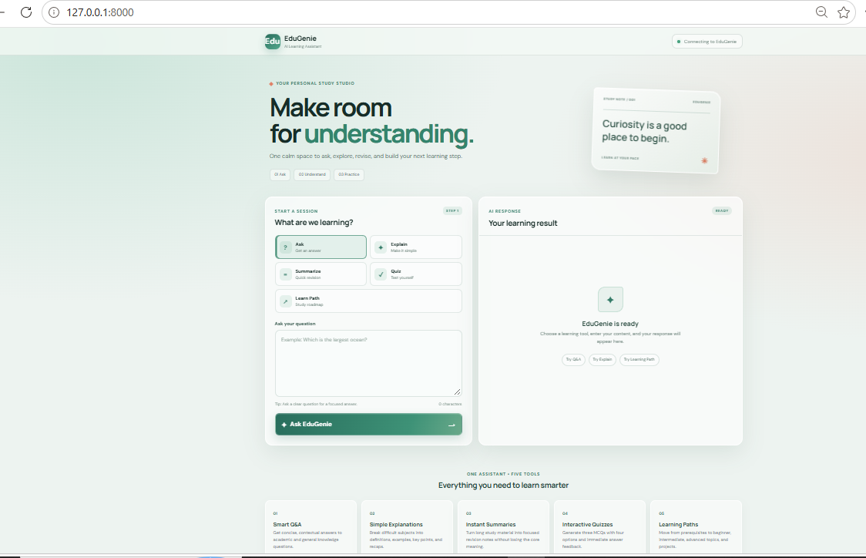
Figure 1. EduGenie home page running locally

Interface guide
Area | Description
Header | EduGenie logo and a status badge that shows the connection to the backend.
Hero section | Tagline "Make room for understanding" with three steps: Ask, Understand, Practice.
Tool selector | Five buttons: Ask, Explain, Summarize, Quiz and Learn Path.
Input box | Text area with a helpful placeholder, tip and character counter.
Action button | Sends the request to the selected endpoint (label changes with the tool).
AI Response panel | Shows the generated result. Quiz results appear as interactive questions with score.
Feature cards | Five cards below the fold that summarize each tool.

9. Setup and Run Locally
These steps are for Windows with Python 3.10 or newer.
- Open Command Prompt in the project folder.
- Create a virtual environment and activate it.
- Install the dependencies.
- Copy .env.example to .env and add your Gemini API key.
- Start the server and open the browser.
Command Prompt
python -m venv venv
venv\Scripts\activate
pip install -r requirements.txt
copy .env.example .env
uvicorn main:app --reload

.env
GEMINI_API_KEY=your_real_key_here
GEMINI_MODEL=gemini-3.8-flash

Page | URL
Web app | http://127.0.0.1:8000
FastAPI docs | http://127.0.0.1:8000/docs
Health check | http://127.0.0.1:8000/health

Security: create your key in Google AI Studio. Never put the real API key in source code or GitHub, and do not commit the .env file.

10. Deployment on Render
The project includes a render.yaml blueprint, so deployment takes only a few clicks.
render.yaml
services:
- type: web
name: edugenie
runtime: python
buildCommand: pip install -r requirements.txt
startCommand: uvicorn main:app --host 0.0.0.0 --port $PORT
healthCheckPath: /health
envVars:
- key: GEMINI_API_KEY
sync: false
- key: GEMINI_MODEL
value: gemini-3.8-flash

Option A: Blueprint
- Push the project to GitHub.
- In Render, create a Blueprint and select the repository.
- Set GEMINI_API_KEY as a secret environment variable.
- Deploy and open the generated Render URL.

Option B: Web Service
Setting | Value
Runtime | Python
Build command | pip install -r requirements.txt
Start command | uvicorn main:app --host 0.0.0.0 --port $PORT
Environment | GEMINI_API_KEY = your real key (optional: GEMINI_MODEL)

11. Demo Guide
Step | Tool | Sample input
1 | Ask | Which is the largest ocean?
2 | Explain | Pythagoras theorem
3 | Summarize | Paste a paragraph about photosynthesis
4 | Quiz | Photosynthesis (answer the 3 questions and show the score)
5 | Learn Path | SQL
6 | API docs | Open /docs to show the FastAPI endpoints

Viva explanation
When a user selects a feature, JavaScript sends a POST request to the matching FastAPI endpoint. FastAPI validates the request using Pydantic. The endpoint calls the corresponding Python module. The module creates an educational prompt and sends it to Gemini. The Gemini response is returned as JSON to the browser, and the frontend renders the result.

12. Troubleshooting

Error: model not found (404)
During testing, the /qa endpoint returned this error:
Error output
500
{"detail":"404 NOT_FOUND ... models/gemini-1.5-flash is not found
for API version v1beta, or is not supported for generateContent ..."}

Cause: the requested model name is retired or not available for your API key.
Fix: set GEMINI_MODEL in .env (or on Render) to a model your key supports, then restart the server. EduGenie will also try the fallback models in gemini_utils.py.

Other common issues
Symptom | Likely cause | Solution
Status badge says "Connecting" | Backend not running or key missing | Start uvicorn, check /health, set GEMINI_API_KEY
503 error | API key not configured | Add GEMINI_API_KEY to .env and restart
400 error | Empty input | Type a question, topic or text first
429 error | Rate limit reached | Wait and retry. The fallback tries another model
Quiz fails to parse | Model returned invalid JSON | Retry, or choose a model that supports structured output

13. Future Enhancements
Area | Idea
Accounts and history | User authentication, learning history, persistent database
Progress | Progress dashboard and adaptive learning based on quiz performance
Input types | PDF and image input, voice interaction
Language | Multilingual learning
Institutions | Teacher and parent dashboard, LMS integration

14. Conclusion
EduGenie shows how a small FastAPI service and the Gemini API can deliver a complete study companion. Its modular design, structured quiz output, model fallback and one-click deployment make it easy to understand, demonstrate and extend.

